Greater Noida
Sr.  No. | Experiments | Date of  Experiment | Submission Date | Sign
1. | Design the following static web pages required for an online book store web site.  HOME PAGE: The static home page must contain three frames. | 03/08/2026 | 12/08/2026
2. | LOGINPAGE: All the login deatils
3. | CATOLOGUE PAGE: The catalogue page should contain the details of all the books available in the website in a table. The details should contain the following:  - Snap shot of Cover Page.  - Author Name.  - Publisher.  - Price.  - Add to cart button.
4. | CARTPAGE: The cart page contains the details about the books which are added to the cart.
5. | REGISTRATION PAGE : Create a“  registration form“ with the following fields  1)Name (Text field)  2)Password (password field)  - E-mailid(text field)  - Phone Number(text field)  - Sex(radio button)  - Date of birth(3 select boxes)  - Languages known(checkboxes–English,  Telugu, Hindi, Tamil)  - Address(text area)
6. | Js VALIDATION: Write JavaScript to validate the following fields of the above registration page.  - Name (Name should contains alphabets and the length should not be less than 6 characters).  - Password (Password should not be less than 6 characters length).
7. | Js VALIDATION:  - E-mailid (should not contain any  invalid and must follow the standard pattern(name@domain.com)  - Phone Number(Phone number should contain 10 digits only).
8. | CSS: Design a web page using CSS(Cascading Style Sheets) which includes the following:  - Use different font, styles:  In the style definition you define how each selector should work(font, color etc.). Then, in the body of your pages, you refer to these selectors to activate the styles.  - Set a background image for both the page and single elements on the page.
Greater Noida
9. | CSS:  - Control the repetition of the image with the background-repeat property.  - Define styles for links as  A:link  A:visited  A:active  A:hover
10. | Consider a small topic of your choice on which you can develop static Webpages and try to implement all topics of html, CSS and Js within the topic. Choose any one topic.  - Your Own Portfolio  - To-Do List  - Survey Form  - A Tribute Page  A Questionnaire

Greater Noida

Experiment 1
Aim: Design the following static web pages required for online book store.
Description –
// Here describe all the important points and tags that used

Home.html
//Description of home page with code and output
This home page has login register etc pages and different books on right frames. <frameset rows="40%,*">
<frame src="top.html" noresize scrolling="NO" name="topframe">
<frameset cols="15%,*">
<frame src="left.html" noresize scrolling="NO" name="leftframe">
<frame src="right.html" noresize name="rightframe" scrolling="auto">
</frameset>
</frameset>

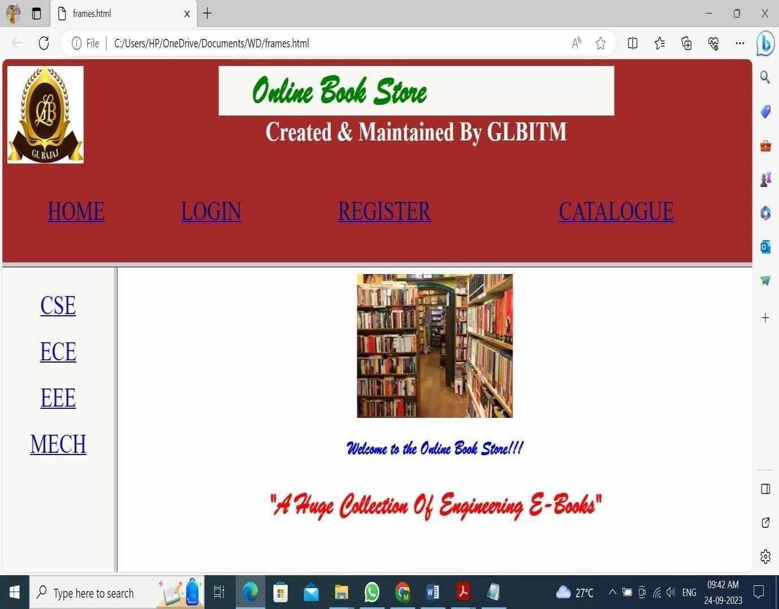
Name: Registration Number:

[Approved by AICTE, Govt. of India & Affiliated to Dr. APJ Abdul GL BAJAJ Kalam Technical University, Lucknow, U.P., India]
Institute _{of Technology & Management} Department of Computer Science & Engineering (Data Science)
Greater Noida

